**Poisson Distribution**

Poisson distribution is a theoretical discrete probability and is also known as the Poisson distribution probability mass function. It is used to find the probability of an independent event that is occurring in a fixed interval of time and has a constant mean rate. The Poisson distribution probability mass function can also be used in other fixed intervals such as volume, area, distance, etc. A Poisson random variable will relatively describe a phenomenon if there are few successes over many trials. The Poisson distribution is used as a limiting case of the binomial distribution when the trials are large indefinitely. If a Poisson distribution models the same binomial phenomenon, λ is replaced by np.

## What is Poisson Distribution?

Poisson distribution definition is used to model a discrete probability of an event where independent events are occurring in a fixed interval of time and have a known constant mean rate. In other words, Poisson distribution is used to estimate how many times an event is likely to occur within the given period of time. λ is the Poisson rate parameter that indicates the expected value of the average number of events in the fixed time interval. Poisson distribution has wide use in the fields of business as well as in biology.

## Poisson Distribution Formula

Poisson distribution formula is used to find the probability of an event that happens independently, discretely over a fixed time period, when the mean rate of occurrence is constant over time. The Poisson distribution formula is applied when there is a large number of possible outcomes. For a random discrete variable X that follows the Poisson distribution, and λ is the average rate of value, then the probability of x is given by:  
f(x) = P(X=x) = (e-λ λx )/x!

Where

* x = 0, 1, 2, 3...
* e is the Euler's number(e = 2.718)
* λ is an average rate of the expected value and λ = variance, also λ>0

### Poisson Distribution Mean and Variance

For Poisson distribution, which has λ as the average rate, for a fixed interval of time, then the mean of the Poisson distribution and the value of variance will be the same. So for X following Poisson distribution, we can say that λ is the mean as well as the variance of the distribution.

Hence: E(X) = V(X) = λ

where

* E(X) is the expected mean
* V(X) is the variance
* λ > 0

## Properties of Poisson Distribution

The Poisson distribution is applicable in events that have a large number of rare and independent possible events. The following are the properties of the Poisson Distribution. In the Poisson distribution,

* The events are independent.
* The average number of successes in the given period of time alone can occur. No two events can occur at the same time.
* The Poisson distribution is limited when the number of trials n is indefinitely large.
* mean = variance = λ
* np = λ is finite, where λ is constant.
* The standard deviation is always equal to the square root of the mean μ.
* The exact probability that the random variable X with mean μ =a is given by P(X= a) = μa/ a! e -μ
* If the mean is large, then the Poisson distribution is approximately a normal distribution.

## Poisson Distribution Table

Similar to the binomial distribution, we can have a Poisson distribution table which will help us to quickly find the probability mass function of an event that follows the Poisson distribution. The Poisson distribution table shows different values of Poisson distribution for various values of λ, where λ>0. Here in the table given below, we can see that, for P(X =0) and λ = 0.5, the value of the probability mass function is 0.6065 or 60.65%.

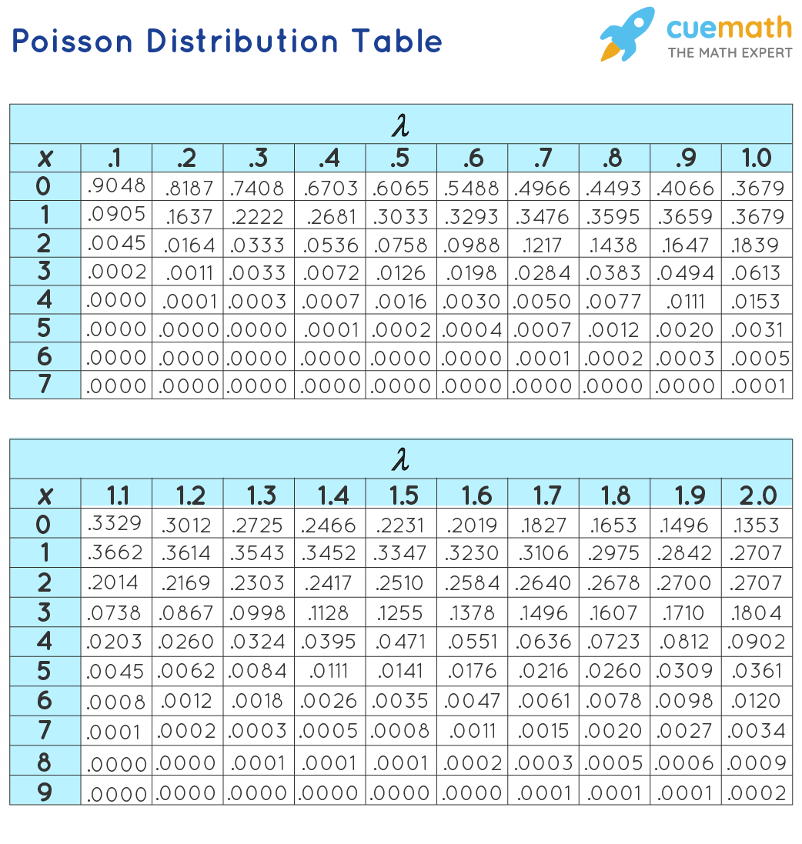

## Applications of Poisson Distribution

There are various applications of the Poisson distribution. The random variables that follow a Poisson distribution are as follows:

* To count the number of defects of a finished product
* To count the number of deaths in a country by any disease or natural calamity
* To count the number of infected plants in the field
* To count the number of bacteria in the organisms or the radioactive decay in atoms
* To calculate the waiting time between the events.

### ****Important Notes****

* The formula for Poisson distribution is f(x) = P(X=x) = (e-λ λx )/x!.
* For the Poisson distribution, λ is always greater than 0.
* For Poisson distribution, the mean and the variance of the distribution are equal.
* **Example 1:**In a cafe, the customer arrives at a mean rate of 2 per min. Find the probability of arrival of 5 customers in 1 minute using the Poisson distribution formula.

**Solution:**

Given: λ = 2, and x = 5.

Using the Poisson distribution formula:

P(X = x) = (e-λ λx )/x!

P(X = 5) = (e-2 25 )/5!

P(X = 6) = 0.036

**Answer: The probability of arrival of 5 customers per minute is 3.6%.**

* **Example 2:**Find the mass probability of function at x = 6, if the value of the mean is 3.4.

**Solution**:

Given: λ = 3.4, and x = 6.

Using the Poisson distribution formula:

P(X = x) = (e-λ λx )/x!

P(X = 6) = (e-3.4 3.46 )/6!

P(X = 6) = 0.072

**Answer: The probability of function is 7.2%.**

In probability and statistics, the normal distribution or Gaussian distribution or bell curve is one of the most important continuous probability distributions. The [normal distribution](https://byjus.com/maths/normal-distribution/) is defined as the probability density function f(x) for the continuous random variable, say x, in the system. A normal distribution is a very important statistical data distribution pattern occurring in many natural phenomena, such as height, blood pressure, lengths of objects produced by machines, etc. Here, we are going to discuss the normal distribution formula and examples in detail.

## Normal Distribution Formula

For a random variable x, with mean “μ” and standard deviation “σ”, the probability density function for the normal distribution is given by:

Normal Distribution Formula:

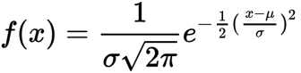Where

μ = Mean

σ = Standard deviation

x = Normal random variable

### Solved Example on Normal Distribution Formula

**Example:**

Find the probability density function for the normal distribution where mean = 4 and standard deviation = 2 and x = 3.

**Solution:**

Given:

Mean,μ = 4

Standard deviation, σ = 2

Random variable, x = 3.

We know that the normal distribution formula is:

Therefore, the probability density function for the normal distribution is 0.17603.